* What problem your app is solving / What needs your app is fulfilling

The intended application solves the problem of not knowing the meaning of a word. Electronic reading systems, such as the Amazon Kindle, provide the ease of simply selecting a word in the text with your finger to display its meaning.

* The intended users

This application is intended for readers of classic printed books, who would still like to quickly access the meaning of an unknown word. The reader can use an Android device to simply snap a picture of the page containing the word. The application will then leverage the power of Google’s Optical Character Recognition (OCR) API to identify the words contained in the picture. The reader can then select the word from the identified words list to show its meaning.

* A list of your project features
  1. Quickly access the definition of any word.
  2. Ability to save the meaning of the words for future reference.
  3. Can use saved pictures as input to the application.

**Activity # 1**

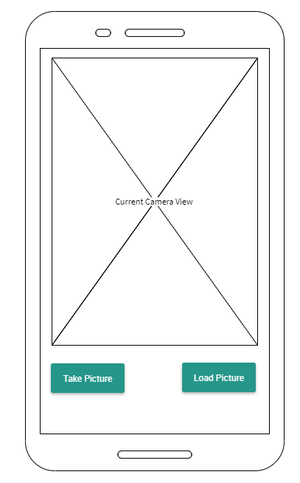

1. Will be first screen shown when user opens application
2. Page will show current camera view
3. User can use the “Load Picture” button to select a saved picture (will load Activity # 2)

**Activity # 2**

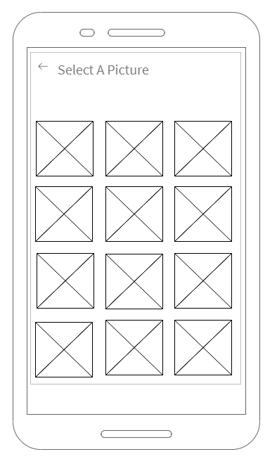

**Activity # 3** 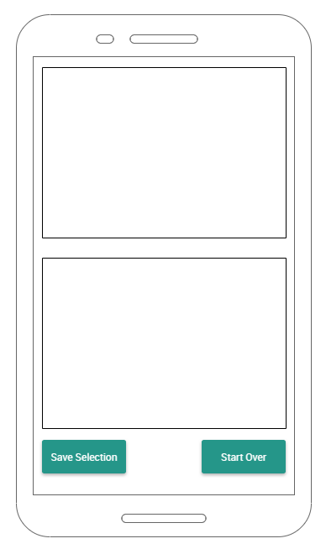

1. Top segment will show the identified words
2. Bottom segment will show the definition of selected word.
3. The “Save Selection” button will allow user to save the definition for future reference.
4. The “Start Over” button will allow the user to return to Activity # 1.